 

Al-Imam Muhammad Ibn Saud Islamic University

College of Computer and Information Sciences

Department of Computer Science

***Research Projects Management System (RPMS)***

***CS438***

**By:**

*Hammam Abdulaziz Bin Ali Jaber (434045250)*

*Khalled Mohammed Naji (435032508)*

*Rakan Imad Al-Khatib (433041170)*

*Tayseer Eyad Swidan (434043211)*

***To:***

**Instructor:** *Dr. Mohamed-Foued Sriti*

Report | Final Version

22/12/201

# Table of Contents

Contents

Table of Contents 1

1 Introduction 2

2 Design 3

2.1 Introduction 3

2.2 Use case diagram 4

2.3 Activity diagram 5

2.4 Relational mapping 6

2.5 Entity relation diagram (ER) 7

2.6 Pages 8

2.6.1 Introduction 8

2.6.2 Homepage with login 9

2.6.3 Registration page 10

2.6.4 Researcher pages 11

2.6.5 Employee pages 14

3 Process 16

3.1 Introduction 16

3.2 Researcher process 16

3.3 Employee process 16

4 Implementation 17

4.1 Introduction 17

4.2 SQL commands 17

4.3 HTML & CSS 17

4.4 JavaScript 17

4.5 PHP 17

# Introduction

First, we understand the system (RPMS) then, we site all the possible process we found to start doing it, after that we draw use case diagram, activity diagram, Relational mapping, and the entity relation diagram (ER) of the system. Then we gathered the photos and all what we need to design for making first prototype of our homepage and all other pages will depend on it, after we agree the final design of our homepage we used a sublime software to write HTML and CSS code to build the pages. We built about 40 Html files and 5 CSS files, the problem that faced us and lit us to build so many pages that we didn’t have enough knowledge in JavaScript, we tried a lot, but we couldn't do it, so we built many pages without using JavaScript. After we finished building pages we created our database then used XAMP to code in PHP.



# Design



# Introduction

We draw all required diagrams in this chapter which are use case diagram, activity diagram, Relational mapping, and the entity relation diagram (ER) of the system.



# Use case diagram

***Research Projects Management System (RPMS)***

**"Extend"**

researcher

**"Extend"**

**"include"**

**"include"**

**"include"**

reviewer

Scientific Research Deanery employee



# Activity diagram





# Relational mapping

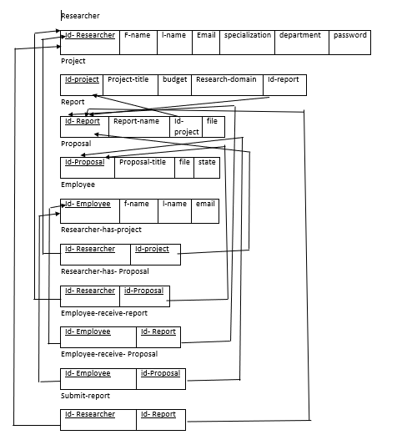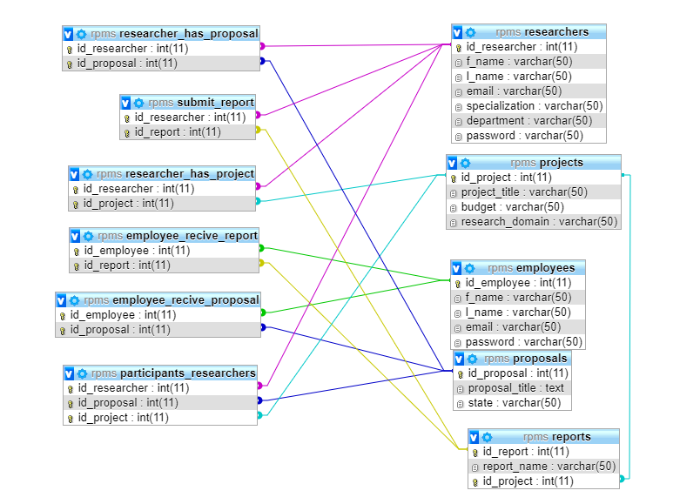

# Entity relation diagram (ER)

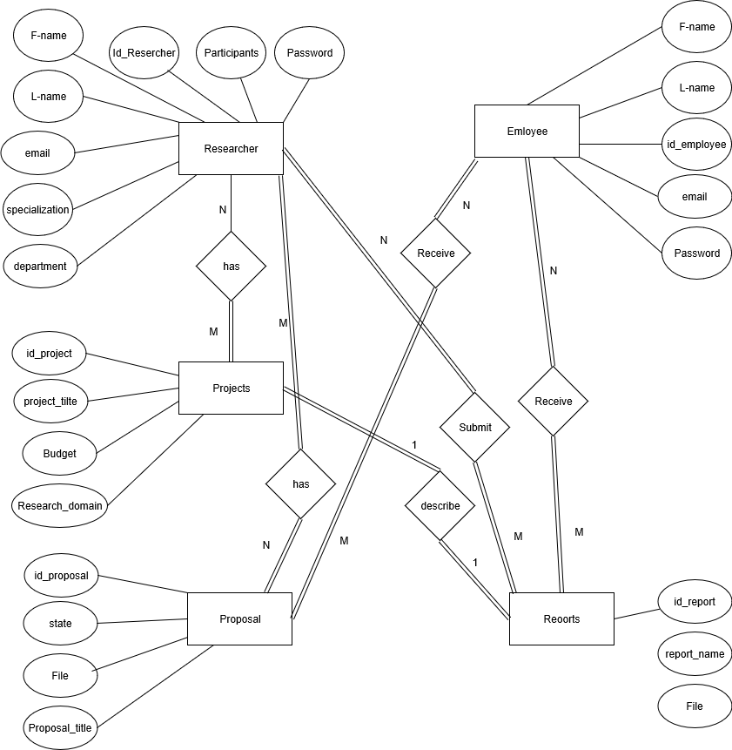

# Pages

# Introduction

Here we will interduce the main pages, we will not introduce all 40 pages we built, and the main pages are Homepage including the login, registration page, Researcher page, and employee page.

# Homepage with login

Main homepage

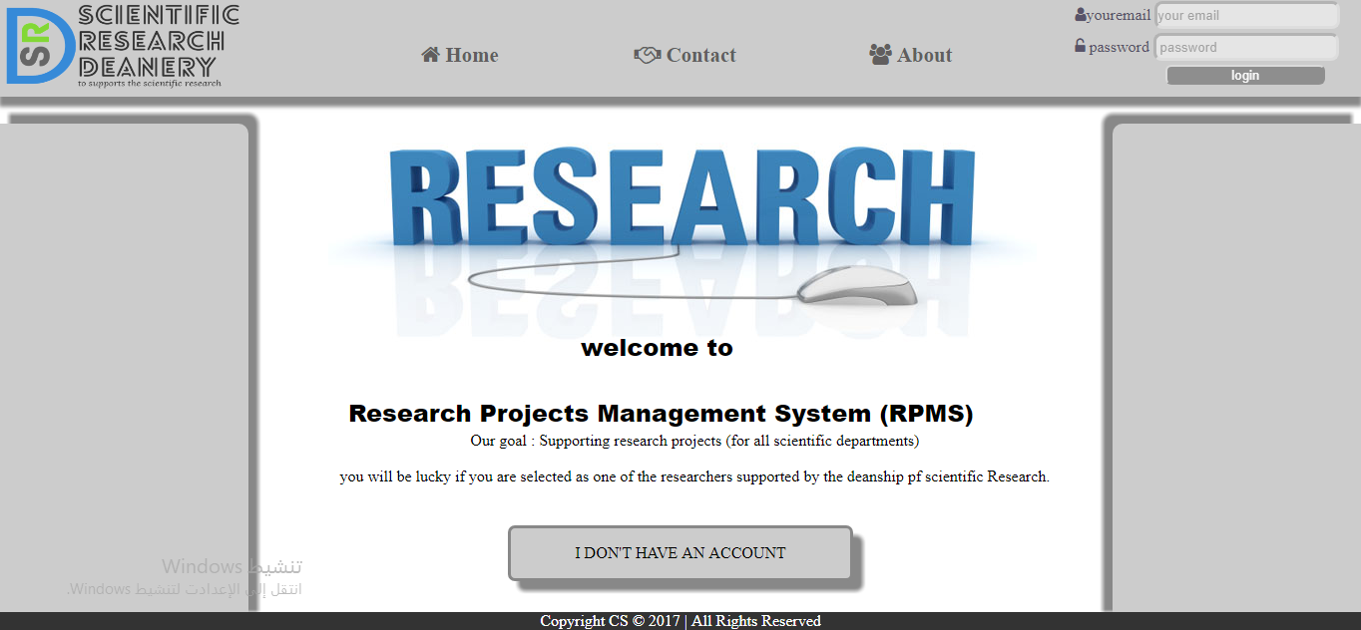

About homepage

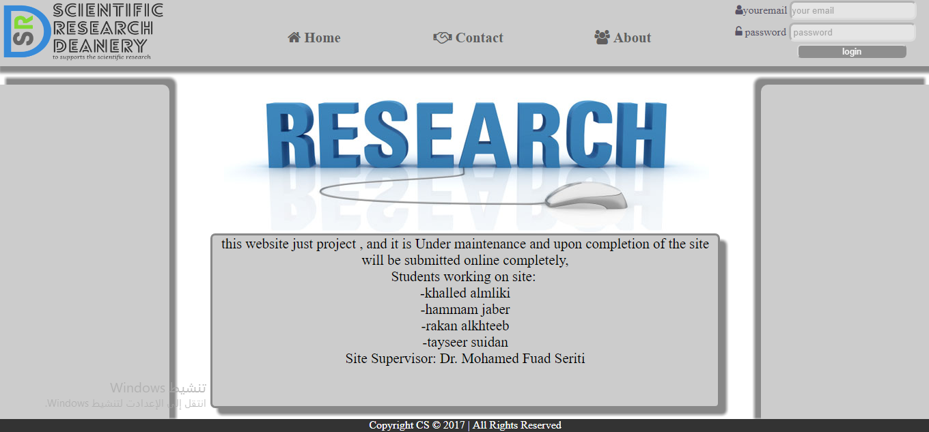

Contact homepage

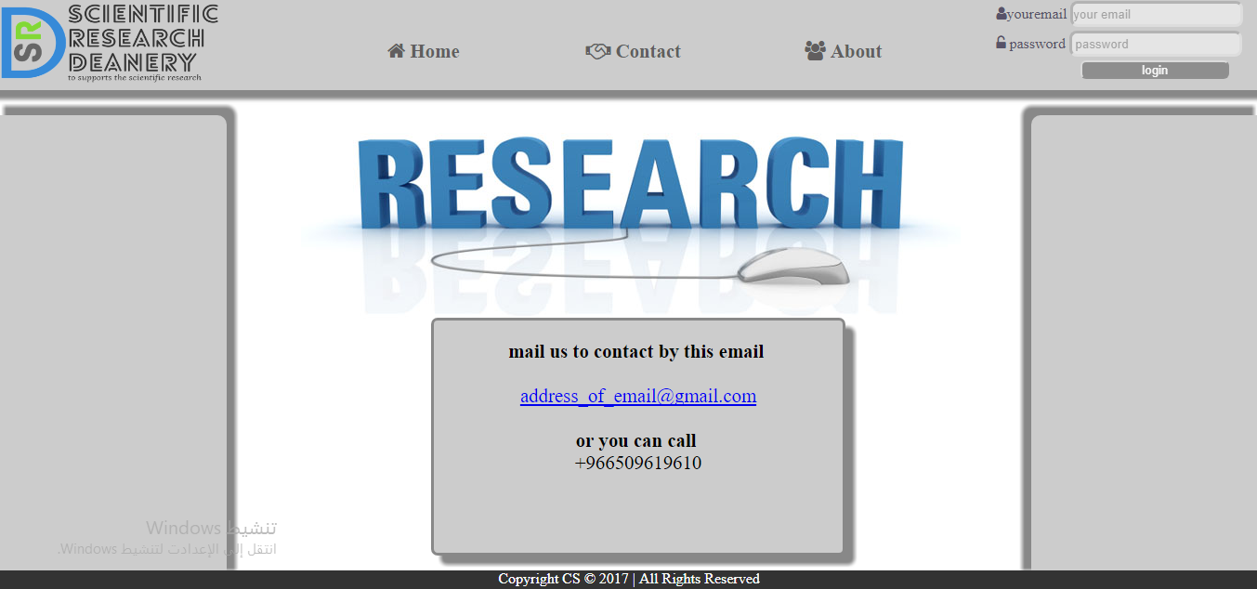

# Registration page

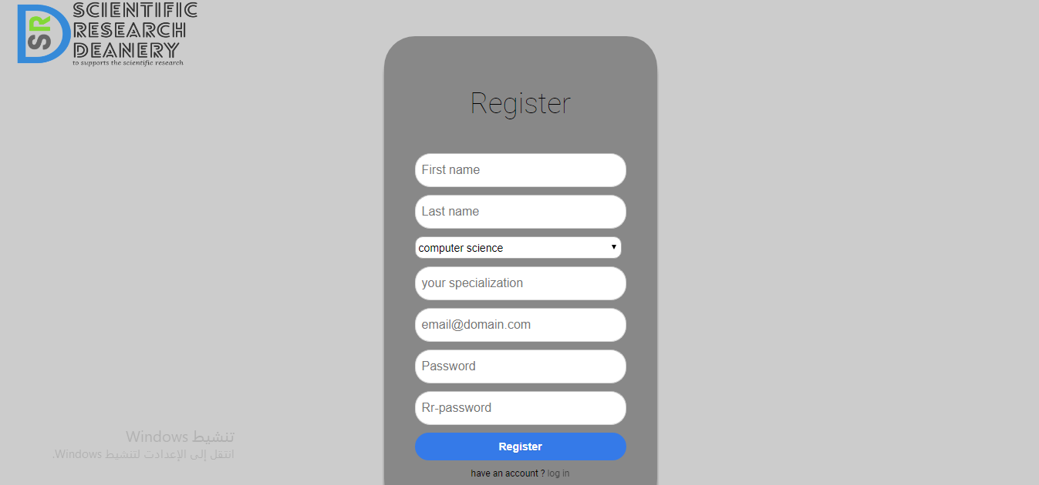

# Researcher pages

Researcher homepage

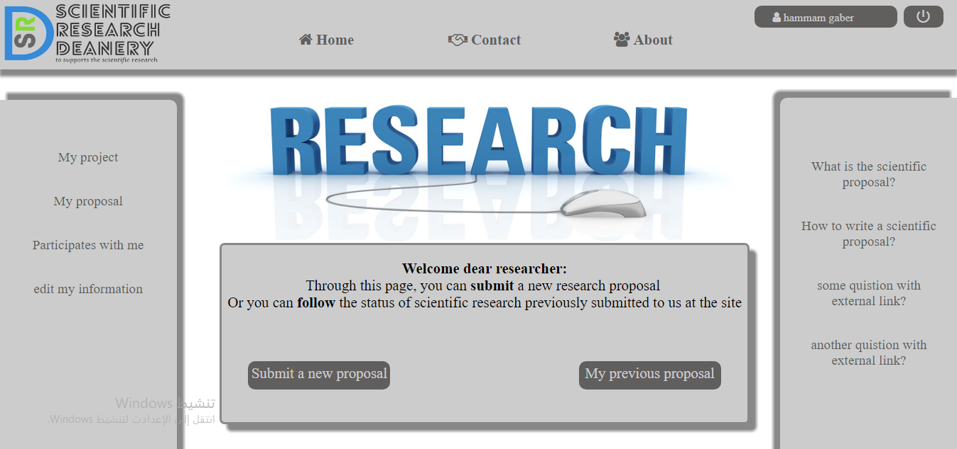

Researcher information page

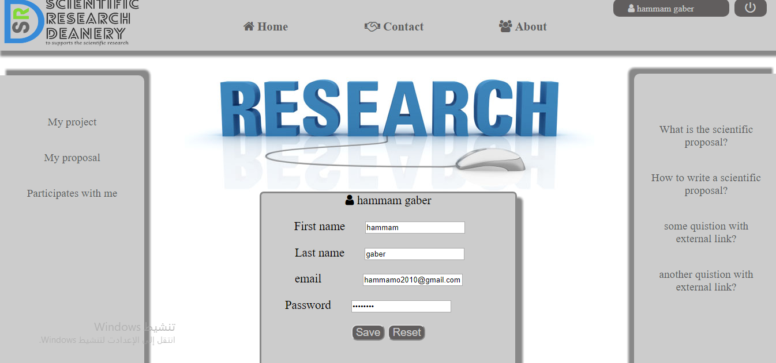

Submit new proposal page

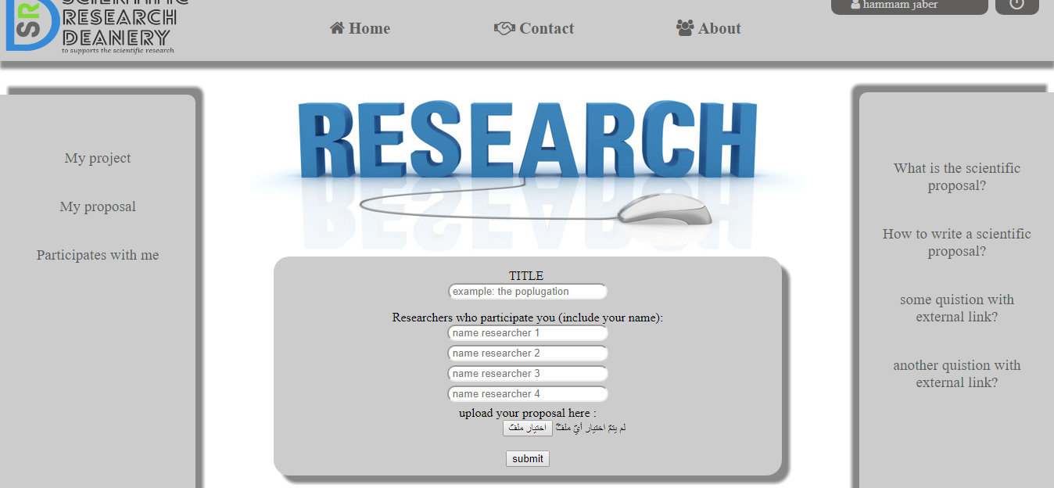

Researcher projects page

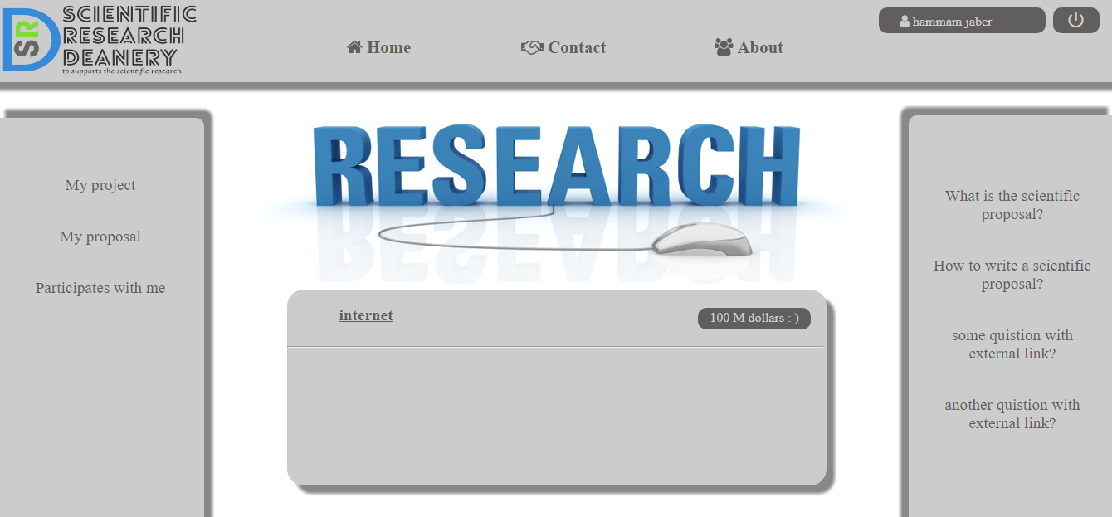

Researchers proposal page and its status

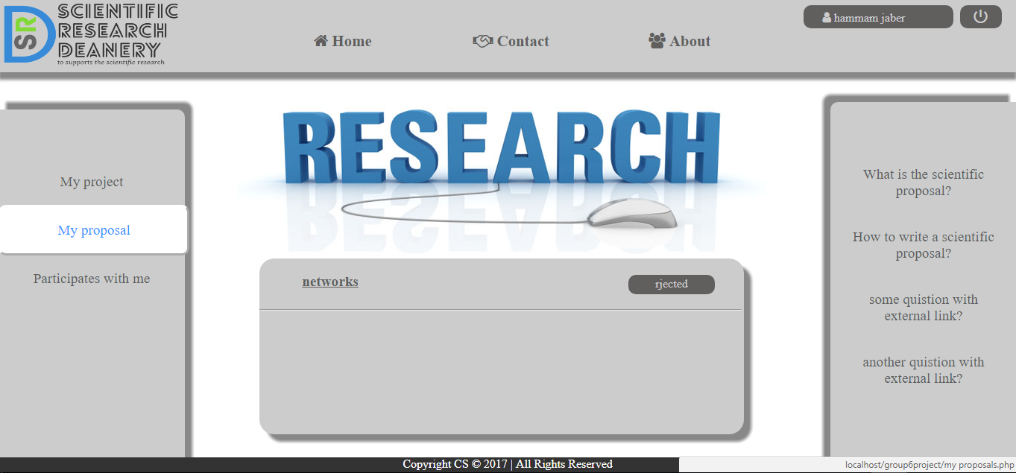

Page of other researchers participate in the same project

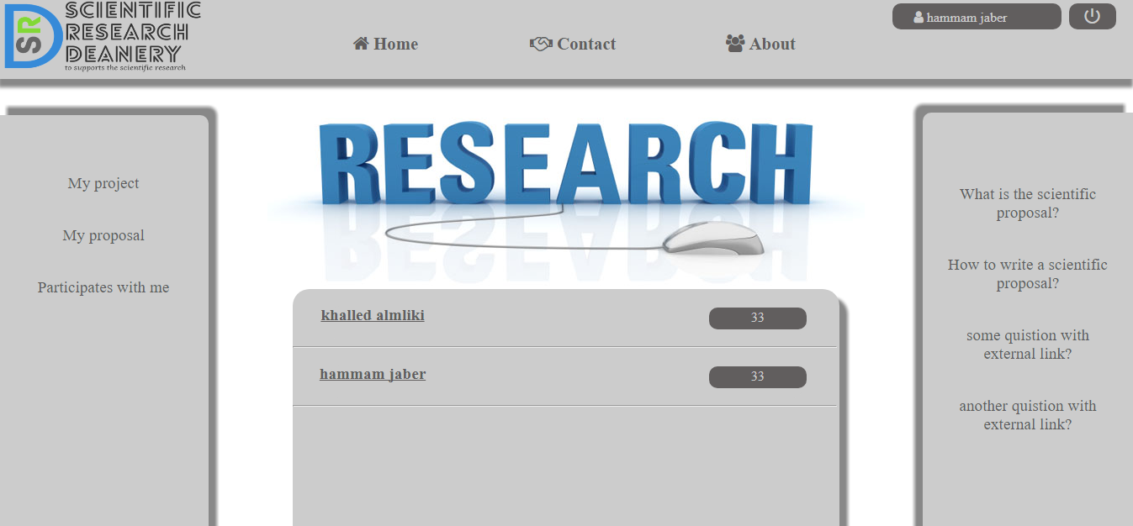

# Employee pages

Employee homepage



Departments page

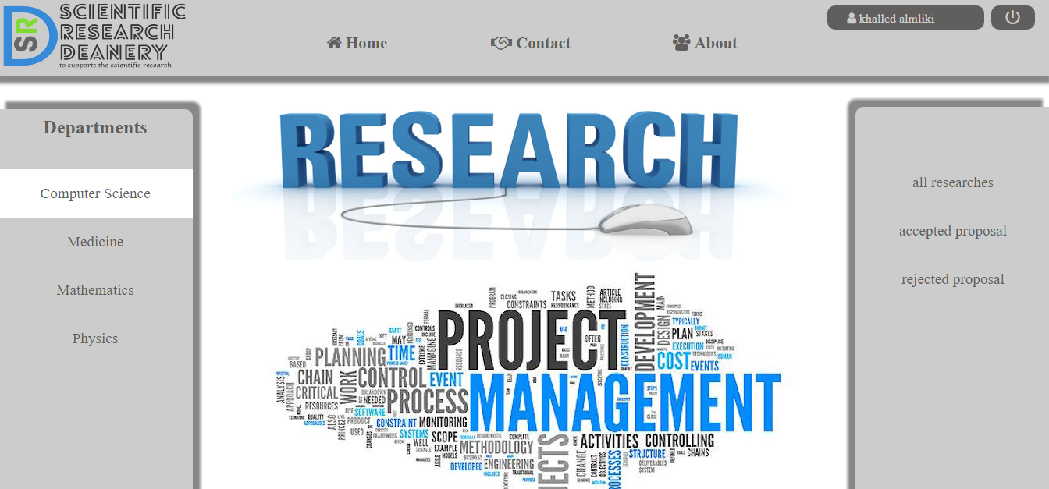

Reperches page

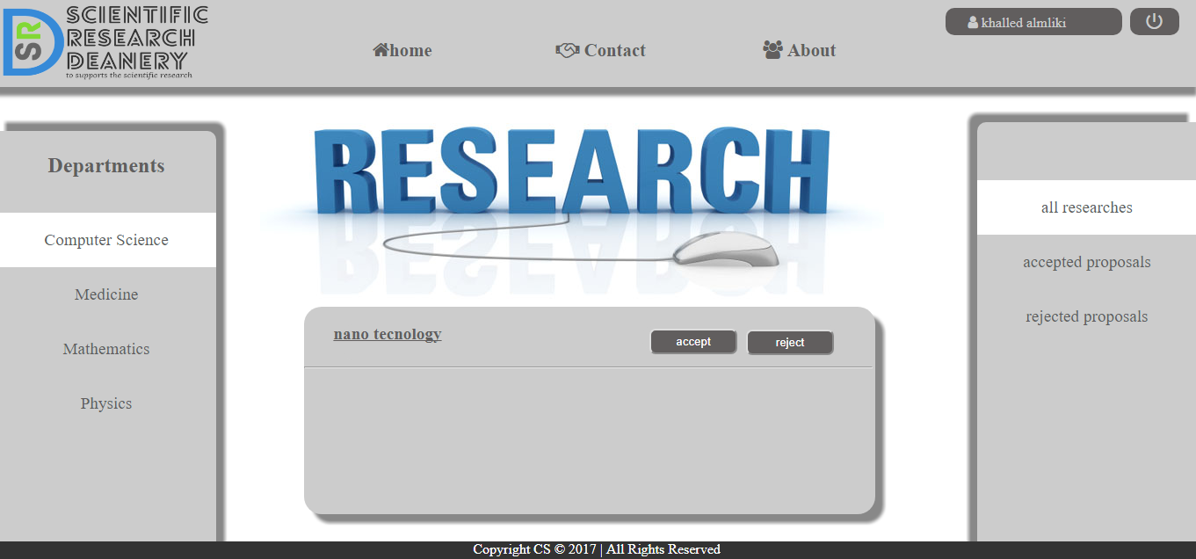

Accepted or rejected proposal page

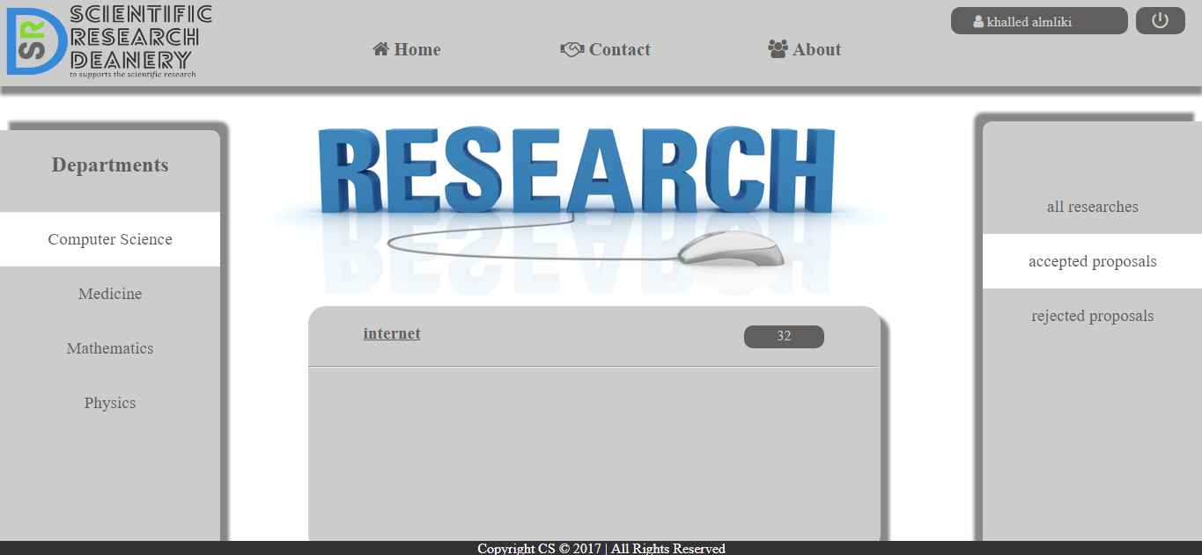

# Process



# Introduction

We have two processes and we are going to implement them in this chapter. The process are researcher process and employee process. So, we will do the steps of each of them then we will code it. In this chapter we will munition all process with its details.

# Researcher process

The process of researcher will begin in the homepage which can login If has an account or register if has not, when he login with no values it will show that you didn’t insert any value, but when he inter wrong values the system will show that you enter wrong password or username, and when he enter the correct information the system will take him to the researcher homepage, in the researcher home page the researcher can see his projects, his proposals, other researcher participates with him, and his information. Researcher also can submit new proposal, can edit his information, and can log out from the page. When the proposal submits a new proposal, he will wait until his proposal being accepted or rejected, if the proposal has been rejected he will know that and he can submit another one, and if the proposal accepted he can now submit a progress reports. The researcher also can become a reviewer and validate the other researches.

# Employee process

The process of employee will begin in the homepage which can login If has an account, but we proposed that he cannot register because he must know his account. The employee must write # before entering his user name in logging in, when he login with no values it will show that you didn’t insert any value, but when he inter wrong values the system will show that you enter wrong password or username, and when he enter the correct information the system will take him to the employee homepage, in the employee home page the employee can navigate between all departments and in each department can see all researches and can send them to reviewer also can see accepted and rejected researches.

# 4 Implementation



# Introduction

The pages that we built are home page, registration page, researcher pages, and employee pages. After introducing all possible processes in previous chapter, we will give full information about how we implemented these processes using HTML, CSS, JavaScript, and PHP.

# SQL commands

We built our database by SQL commands. We created SQL commands by fill all table and drag and drop so we didn’t have the code of it but after creating them we imported them in a zip file then we could move them to any other device by export the zip file into the database. The zip file is included with files of the project also it allows us to see the code by open the file with the note.

# HTML & CSS

We built all pages in HTML and enhance them by separated files of CSS. HTML files are included in PHP files, we wrote about 40 pages, and CSS files are separated of them but some of CSS codes we wrote it inside the HTML files.

# JavaScript

We didn’t use separate files of JavaScript because we didn’t write much code in JavaScript, but JavaScript is included in PHP files we use it in logging in and some functionality, but we didn’t use it in HTML codes and that’s why the pages are so much.

# PHP

We uploaded our database to the server side using PHP. All the files of the pages are in PHP exertion, but inside the files also we used HTML, CSS, and JavaScript codes.